Program Structures and Algorithms

Spring 2023 (SEC—8)

NAME – Abhinav Ankur

NUID – 002747605

**Task** –

Implement Part 1 for three (3) methods (repeat, getClock, and toMillisecs) of a class called Timer. Part 2 Implement InsertionSort (in the InsertionSort class) by simply looking up the insertion code used by Arrays.sort. Part 3 Implement a main program (or you could do it via your own unit tests) to actually run the following benchmarks: measure the running times of this sort, using four different initial array ordering situations: random, ordered, partially-ordered and reverse-ordered.

***Part 1***

**Repeat**

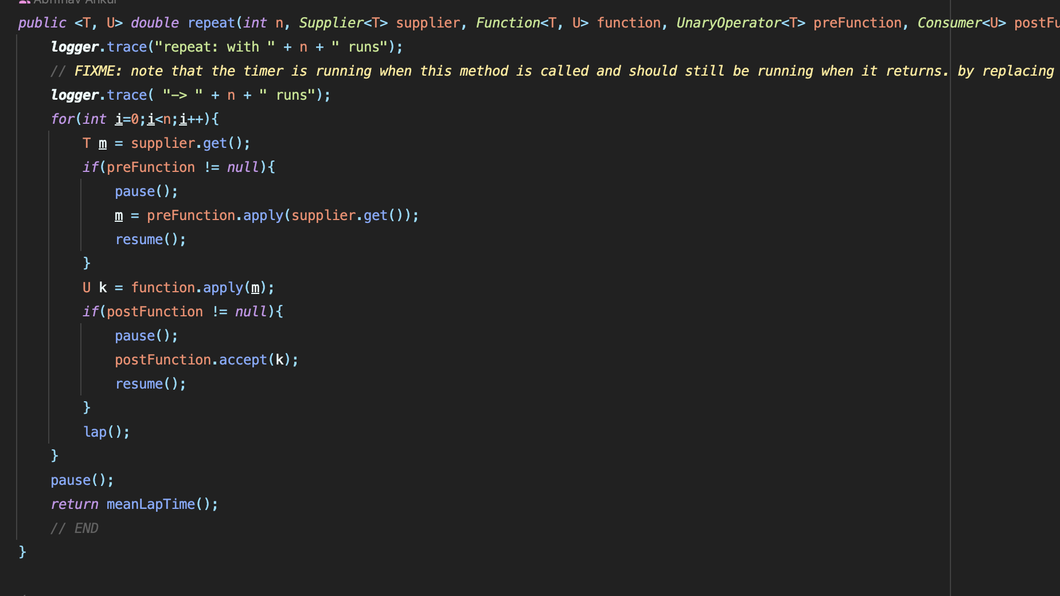

**Get Clock**

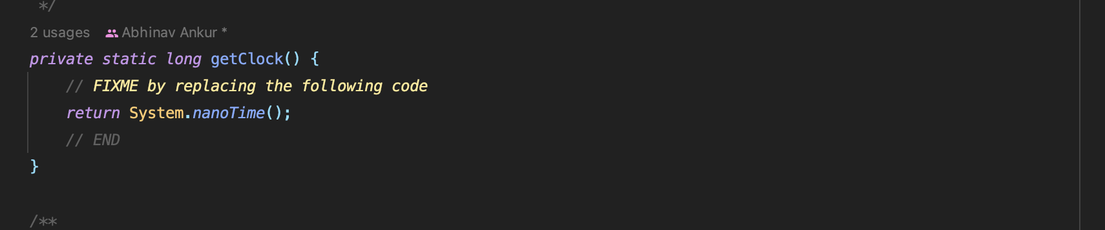

**toMillisecs**

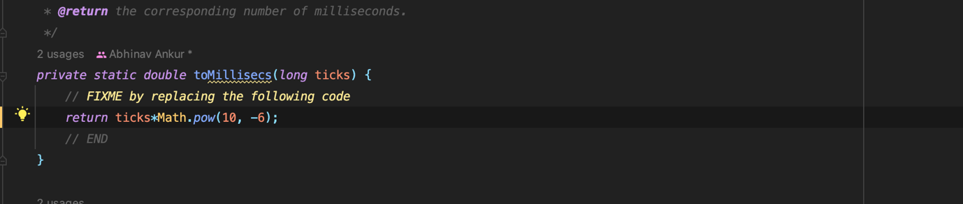

***Part 2***

Insertion Sort

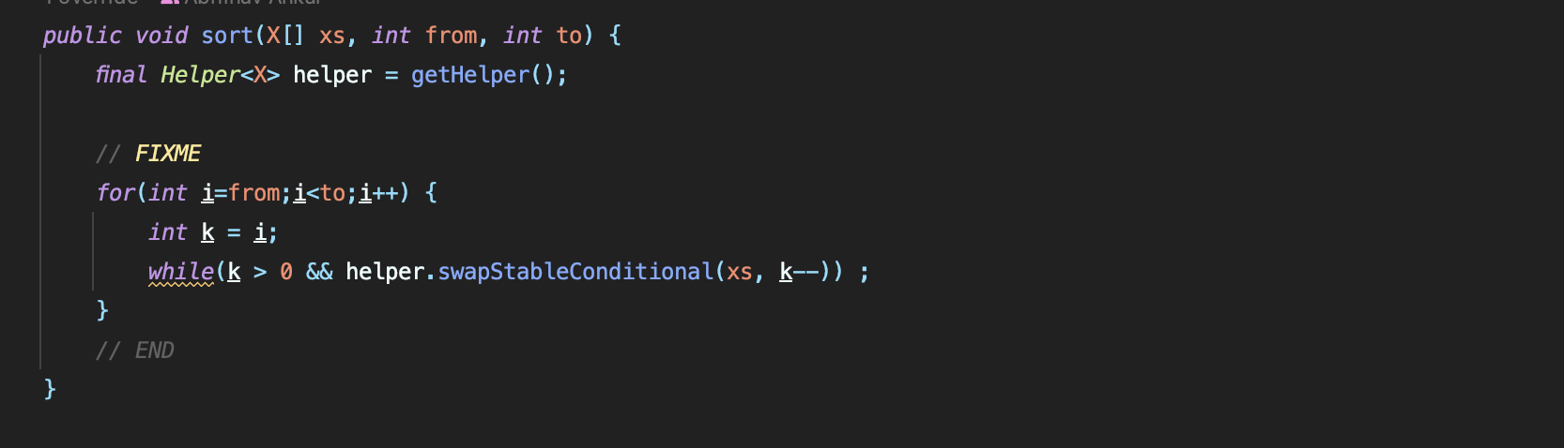

***Part 3***

Main class

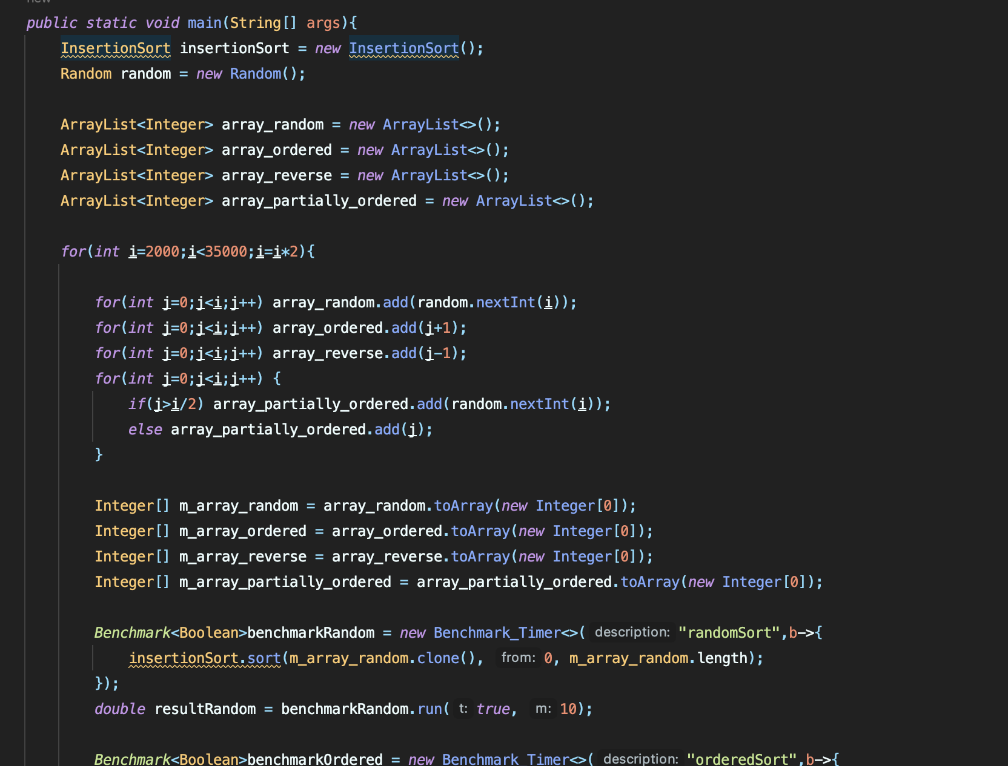

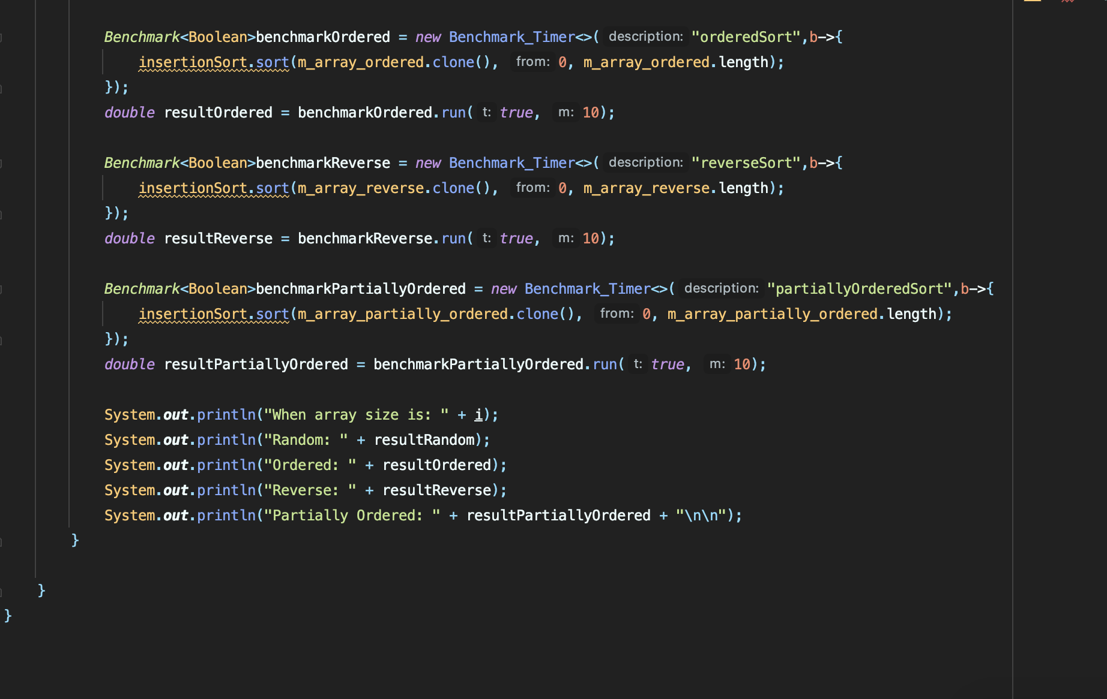

***Test case***

**Part 1 Timer Test**

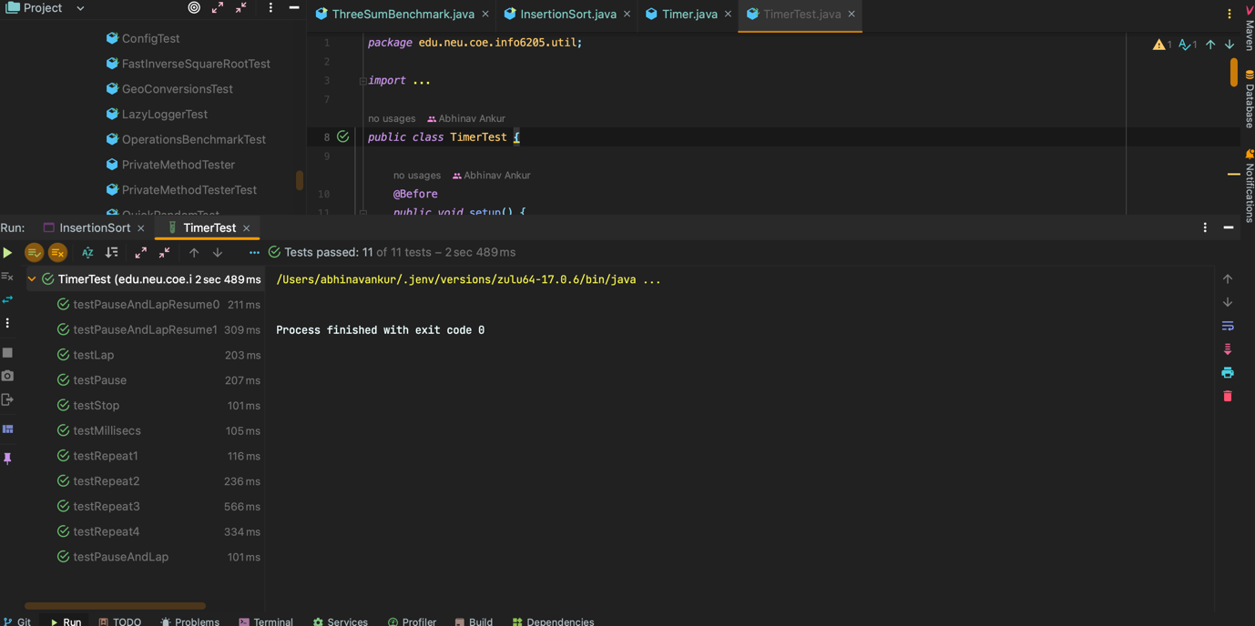

**Benchmark test**

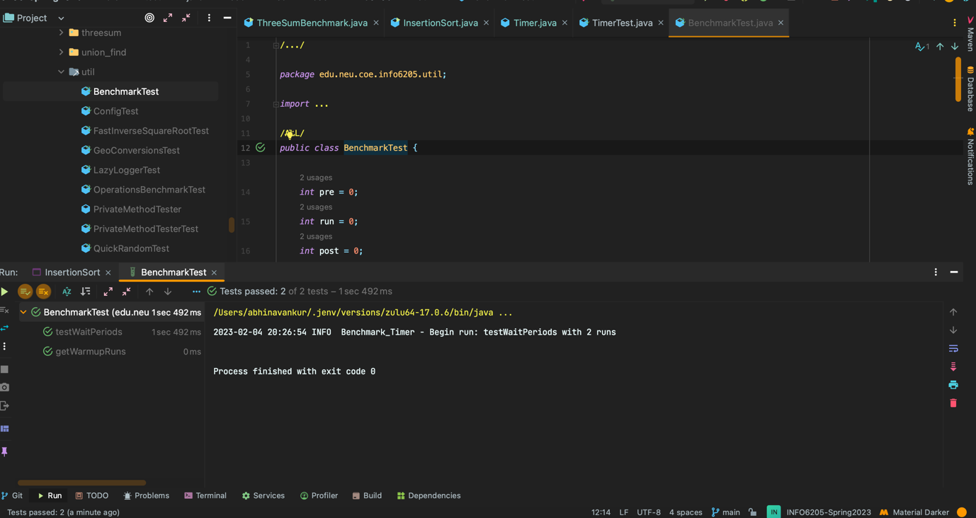

**Insertion sort test**

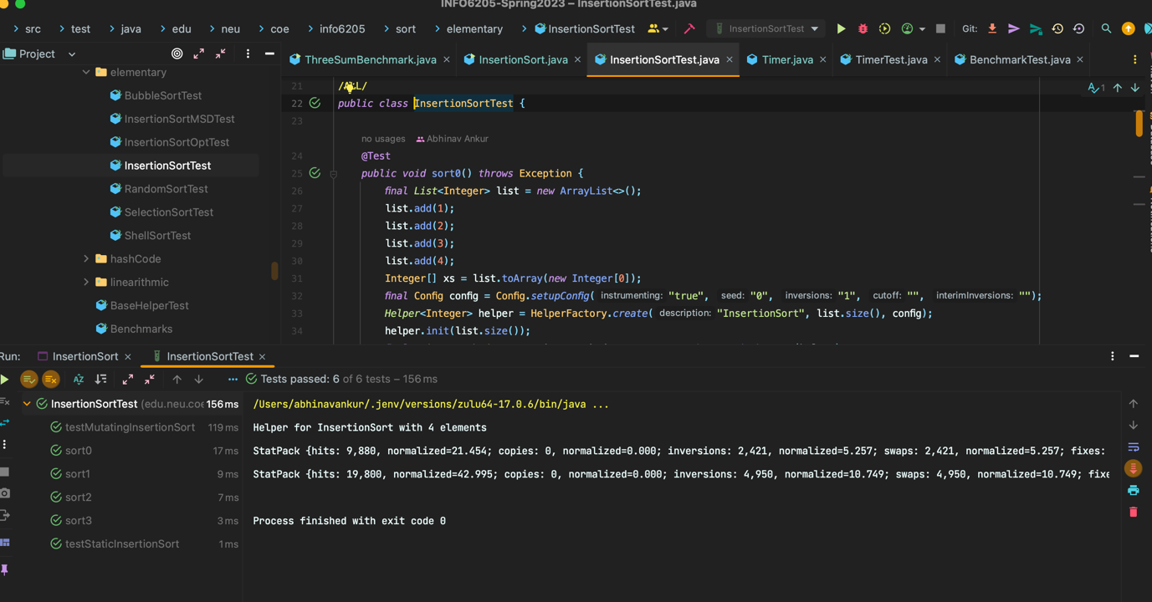

Observations

1 Partial sorted array

Slope is approximately 2

When we double the size of array, the time taken increases approximately by a factor of 4.

The order of growth is quadratic

2 Reverse sorted array

Slope is approximately 2

When we double the size of array, the time taken increases approximately by a factor of 4.

The order of growth is quadratic

3 Ordered array

The time for sorting the array increases slightly when the size of array increases.

The order of growth is linear

4 Randomly sorted array

Slope is approximately 2

When we double the size of array, the time taken increases approximately by a factor of 4.

The order of growth is quadratic

Conclusion

The time taken for sorting different arrays in ascending order is

Ordered Array > Partially Ordered Array > Randomly Ordered Array > Reverse Ordered Array

